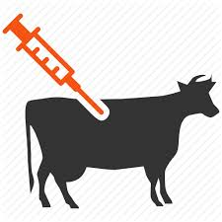

How vaccines work

Firstly we need to know how the immune system defends us against contagious deceases. When foreign micros invade the animal’s body their immune system triggers a series of responses in an attempt to identify and remove them. The main focus of vaccines is to help the immune system adapt to the attacking viruses so they might defend themselves. There are special B-cells and T-cells that are used to fight microbes and also record information about them then creating a memory of what the invaders look like and the best method to fight them. Vaccines are used to ready the body of the host so that they might be protected against the attacking virus. Scientists use the same principles which the body uses to adapt to viruses but without exposing the animals to the full strength decease.

There are many different vaccines which have been created for the specific virus types. There are (live attenuated vaccines) and these are made of the pathogen itself. They are a much weaker and tamer version. There are also (inactive vaccines) in which the pathogens are killed. The reason they are weakened or killed insures that they don’t develop into the full decease. Vaccines teaches the body to create a profile with paths and records so they might recognize an attack.

Animals are exposed to many viruses but the most common are:

* Rabies (this can be spread to people)
* Equine influenza
* CircoFLEX
* Anthrax vaccines
* Brucellosis vaccine
* Canine parvovirus infection ("parvo")
* Canine distemper.
* Leptospirosis.
* Canine adenovirus-2.
* Canine parainfluenza.
* Canine enteric coronavirus.
* Canine influenza.

Rabies vaccine

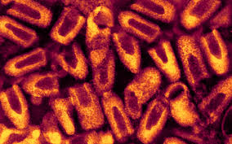

Vaccination are used in two different situations:

Firstly to protect those who are at risk of exposure to the virus. Secondly to prevent the development of after exposure occurred in the bodies. Rabies immunoglobulin is used in the post-exposure prophylaxis.

Pre-exposure vaccination

This vaccination will only work for animals who have not yet been infected by the virus. People are also protected against the threat if they respond early and prepare themselves for any type of situations that might cause infection. There are two types of vaccines for rabies namely modern cell-culture and embryonated-egg vaccine. They are injected in three doses which occur on day 0, 7 and 21 of the month in 0.5/1ml doses.

